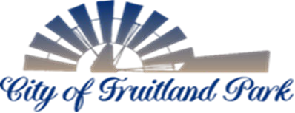

506 WEST BERCKMAN STREET PHONE: 352 360-6727
FRUITLAND PARK, FL 34731 FAX: 352 360-6652

TRC COFP Members: | TRC Members:
City Manager Gary La Venia, Chairman | City of Leesburg Utilities
Police Chief Eric Luce, Vice Chair | Lake County School Board
City Attorney | Lake County Public Works Department
Building Official | Lake County Economic Development
Community Development Director
Code Enforcement Officer
Engineer - Halff
Fire Chief
Fire Inspector
Land Planner LPG
Public Works Director

AGENDA
TECHNICAL REVIEW COMMITTEE
NOVEMBER 1, 2022
10:00AM

- MEETING START TIME:

- MEMBERS PRESENT:

- MEETING NOTES FROM PREVIOUS MEETING: Meeting minutes from October 4, 2022 included for review/comment.

- OLD BUSINESS: NONE

NEW BUSINESS:

- Ralph W. Thiele – Unity of Title (Alternate Keys: 1699673 & 2562684)

Application for Declaration of Unity of Title for properties located at 35417 & 35421 Micro Racetrack Road (alternate keys 1699673 & 2562684, respectively) submitted by Sharon King, PA on behalf of the owner, Ralph W. Thiele. The owner is seeking to make the property wide enough for building to be constructed according to the city’s Land Development Regulations (LDRs).

TRC Meeting November 1, 2022
Page 2 of 2

BOARD MEMBERS’ COMMENTS:

PUBLIC COMMENTS:

This section is reserved for members of the public to bring up matters of concern or opportunities for praise. Note: Pursuant to F.S. 286.0114 and the City of Fruitland Park’s Public Participation Policy adopted by Resolution 2013-023, members of the public shall be given a reasonable opportunity to be heard on propositions before the Planning and Zoning Board. Pursuant to Resolution 2013-023, public comments are limited to three minutes.

ADJOURNMENT:

