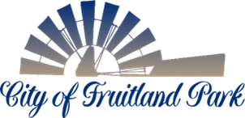

Vacant City Commission Seat

The City Commission for the City of Fruitland Park will appoint an individual to fill the vacant District 3 City Commission seat. The appointment will be for a short-term of office. To be considered for appointment, applicants must have been residents of District 3 for one year prior to appointment and must be registered voters in Lake County.

A map of District 3 may be viewed at:

www.fruitlandpark.org/media/20381

The City Commission is expected to consider appointments at its July 9, 2026, City Commission meeting. The individual appointed will serve until the next city election which will be held November 3, 2026. Applications will be accepted through July 1, 2026. The application can be found below.

City Commission meetings are held on the 2nd and 4th Thursday of each month at 6:00 p.m. Additional workshops and special meetings may be scheduled periodically as needed.

The City of Fruitland Park operates under a Commission-Manager form of government. The City Commission consists of five members elected by District. Each year the Commission selects one of its members to serve as Mayor. The Commission’s responsibilities generally include adopting local ordinances, establishing policy, approving the annual budget, and considering development matters within the City. The City Manager is responsible for day-to-day administration of City operations and reports directly to the City Commission.

Individuals interested in learning more about the City of Fruitland Park or the responsibilities of serving as a City Commissioner are encouraged to contact City Manager Karen Manila at (352) 801-7063 or kmanila@fruitlandpark.org.

Posted June 15, 2026

